# COMP 4513 Assignment #1: Data-Driven PHP and JavaScript *(part 0)*

#### Version 1.0. Due Tuesday February 23, 2016 at 11am

## Overview

This multi-part group assignment will be a part review/refresh of PHP, and part new exploration of JavaScript. Unlike assignments from me in previous years, this one will be in two parts: both will be due at the same time but the first part should be completed before the second. Groups can contain three or four people. Please don’t ask to be a group of five, eight, eleven, or any other number larger than four.

## Submitting

You will not be submitting your source code. Instead, I will mark your code from a GitHub repository. I will mark the functionality by visiting some type of live server. Thus, you will submit your assignment by emailing me a short message consisting of the group member names, the GitHub repository URL, and the web address where I will be able to find your working assignment.

## Grading

The grade for this assignment (both parts) will be broken down as follows:

Visual Design and Styling 15%

Programming Design 15%

Functionality (follows requirements) 70%

## Data Files

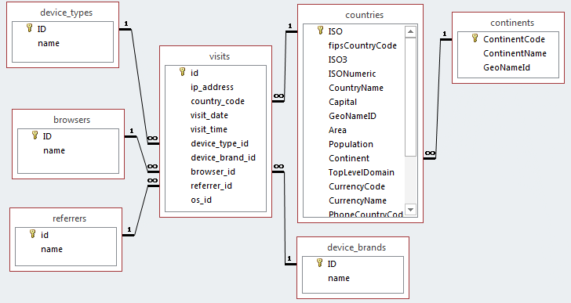You have been provided with the necessary SQL script that you will need to import into MySQL. It represents some analytic information for some web site. I have also included a Microsoft Access version if you want to use that to experiment with queries. The SQL script is quite large so you may have to modify some of your environment’s defaults. Alternately, you can import the zipped version instead.

## Overview

In this assignment you will be creating an **Admin Dashboard** for the data in the visits database. An admin dashboard is a set of user interface elements and menus that give the user quick access to information. Usually, admin dashboards will contain information such as messages, notifications, graphical stats, entry count, analytics, schedules, and so on.

## Requirements

1. You will NOT use Bootstrap!   
     
   Instead I would like you to use a “lite” CSS framework that is based on Google Material Design principles. For a quick introduction to Google Material, visit http://materialdesignblog.com/making-use-of-googles-material-design-guide/. To learn more about Google Material, please read through https://www.google.com/design/spec/material-design/introduction.html.  
     
   Some examples of “lite” implementations of Material include Materialize CSS or Material Design Lite. To find out more, visit http://www.sitepoint.com/top-5-material-design-frameworks-use-2015/. Although you will not be using bootstrap, you might want to do some web searches for “admin templates” to get some ideas about the basic visual design of a typical admin dashboard.
2. To begin, you are going to want to create a working data access layer in PHP. I have provided the code from Chapter 14 in the book from which you can begin. Your table gateway class for the visits table is going to need the most functionality. It will need the ability to filter and count by country code, browser, device type, device brand, and referrer. It will also need the ability to filter by date: for instance, visits in the past month, or between date ranges.
3. To demonstrate this functionality, create a page using your admin design that displays three material cards. Cards one and two should be in the same layout column; the third card should be “besides” the other two:  
     
     
     
     
     
   In the first card, it should display a table of browser names and their percentage of the visits.  
     
   In the second card, it should provide a drop-down list of device brands. When the user selects a brand, it should display in the same card a count of how many visits there have been for that brand.   
     
   In the third card, it should provide a drop-down list of continents. When the user selects a continent, it should display in the same card a material table of the countries from that continent and a count of how many visits from that country.

1

2

3